

SCHOOL OF

COMPUTER SCIENCE

AND IT

DEPARTMENT OF

BACHELOR OF

COMPUTER APPLICATIONS

**Introduction to Linux**

CIA (FINAL)

**Subject Code:** 20BCA5D21

**Class:** I Year I Semester

**Prepared By:**

Suman Garai

20BCAR0246

**Question 01 :** Create a data file called ‘employee’ in the format given below:

   a. EmpCode    Character

   b. EmpName   Character

   c. Grade           Character

   d. Years of experience  Numeric

   e. Basic Pay     Numeric

For example:

A001       ARJUN       E1      01      12000.00

A006           Anand         E1      01      12450.00

A010           Rajesh         E2      03      14500.00

A002           Mohan         E2      02      13000.00

A005           John             E2      01      14500.00

A009           Denial Smith E2      04      17500.00

A004           Williams      E1      01      12000.00

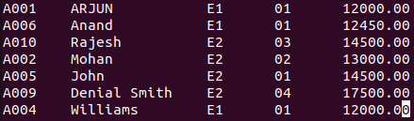

 Perform the following operations on the file:

* Sort the file on EmpCode.

Code & Output:

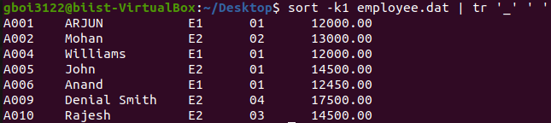

* Sort the file on: - Decreasing order of basic pay.

Code & Output:

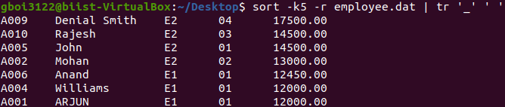

* Sort the file on: - Increasing order of years of experience

Code & Output:

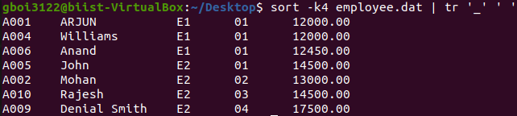

* Display the number of employees whose details are included in the file.

Code & Output:



* Display all records with ‘smith’ a part of the employee name.

Code & Output:



* Display all records with EmpName starting with ‘B’.

Code & Output:



* Display the records on employees whose grade is E2 and have work experience of 2 to 5 years.

Code & Output:



* Save the names of all employees whose basic pay is between 10000 and 15000 in a file ‘employee1’

Code & Output:

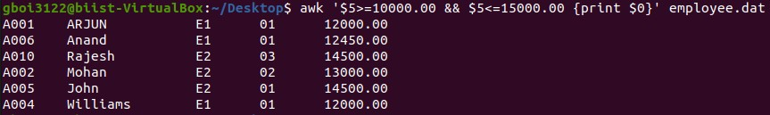

* Display records of all employees who are not in grade E2.

Code & Output:

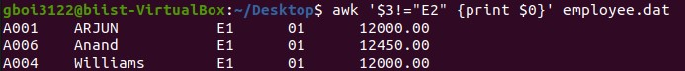

**Question 2 :** WAP to take a file as a command-line argument and reverse the contents of the file and save it in a new file.

Code:

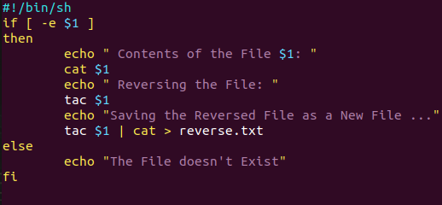

Output:

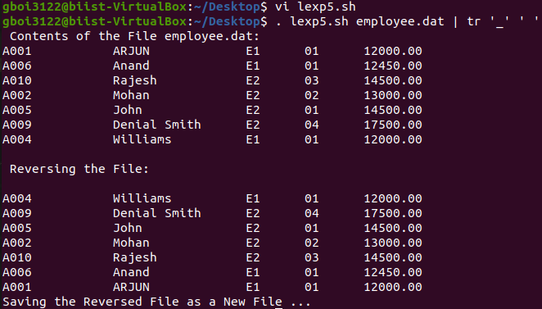

**Question 3 :** WAP which displays the following menu and executes the option selected by the user: -  1. ls -l    2. pwd      3. ps -fe

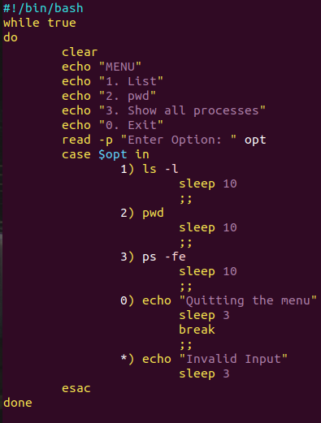Code:

Output:

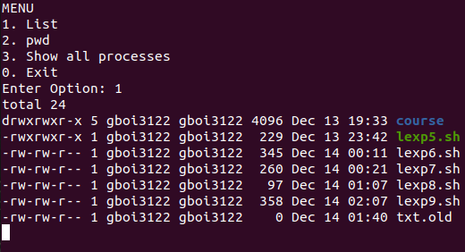

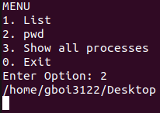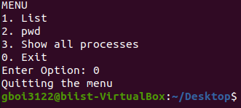

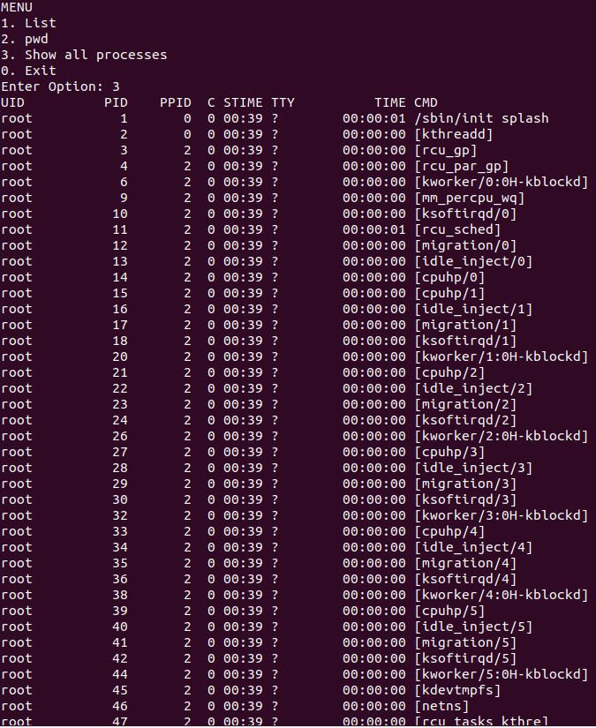

-- THE END --